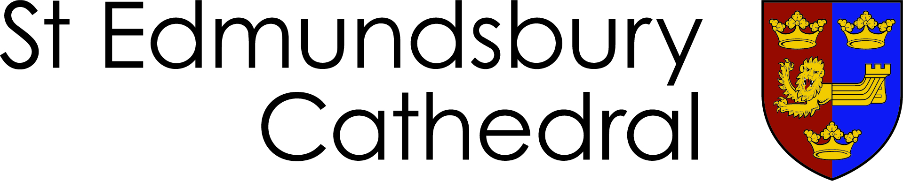

From the Canon Pastor & Sub Dean

Forum Membership
reestablishing the annual election of a proportion of members

For Forum discussion and decision
November 2025

The rewriting of Forum’s Terms of Reference in 2023/4 led to 11 (out of 14) members of Forum being elected at the 2024 APCM (see Forum membership overleaf). If those members’ 3 year term ends at the same time, we will need to replace more than a majority of Forum members in 2027 and none in 2026. That is out of step with the ideal rotation of around a third of Forum members each year – as has been the pattern in the past.

The Terms of Reference (attached) state:
Fourteen people on the Cathedrals’ electoral roll elected for a term of three years by those on the electoral roll at an Annual Parochial Church Meeting, with possibility of re-election for further terms of three years.

A neat solution (requiring a generosity of spirit from some members!) would be for 5 or 6 members of Forum to step down voluntarily ahead of the 2026 APCM. They would be eligible for re-election and beginning a new 3 year term, if they desired. (This would still leave an unequal number of members being elected at each APCM, but that’s manageable and the annual rotation of members will have been re-established.)

Other solution suggestions are welcome!

Cathedral Forum 2025/2026

Dean Very Revd Joseph Hawes
Residentiary Canons Canon Matthew Vernon
Canon Katy Cunliffe

Licensed Lay Ministers Caitlin Brinkley (Reader)
Fiona Knapp (Children’s and Young Families Minister)

Chief Operating Officer Sarah-Jane Powell

Cathedral Wardens Barbara Pycraft
Terry Stark

Elected * until 2027 Penny Bentley, Judy Broadway, Sue Cockram,
Kierstan Foreman, James Mansfield, Valerie Moore,
Dan Soper, Liz Steele, Abbi Thorpe,
Catherine Walsh, Simon Waters

Elected * until 2028 Liz Rowlands, Alice Sheepshanks, Felix von Nathusius

* Elected at the Annual Parochial Church Meeting

