**FRIENDS OF ST EDMUNDSBURY CATHEDRAL**

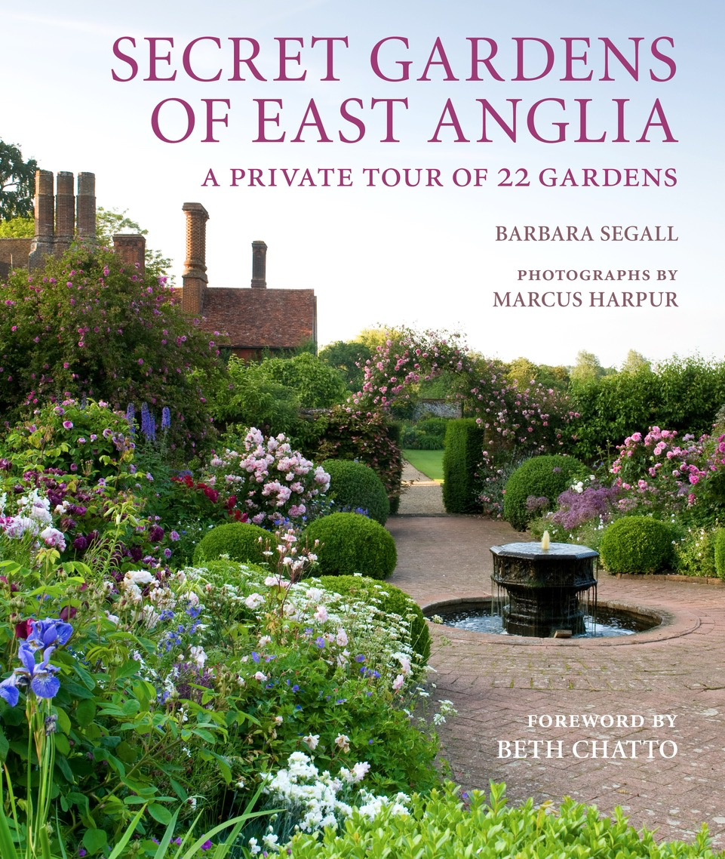

**Come and join us for the sixth of our “Quirky Talks”**

**on Wednesday 8 October 2025 at 2.15pm.**

**“Secret Gardens of East Anglia”**

We are delighted that Barbara Segall, a local author, has agreed to come and tell us about the Secret Gardens of East Anglia - including some beautiful ones in Suffolk. Most of these gardens are now open to the public but one or two are not so it will be fascinating to see ‘over the garden hedge!’ The afternoon will conclude with delicious homemade tea. There is plenty of parking available and we look forward to seeing you all there – do bring your friends!

***VENUE Drinkstone Village Hall, Gedding Road, Drinkstone, Suffolk IP30 9TN***

***DATE Wednesday 8 October 2025***

***TIME 2.15PM***

***COST £20.00 per person***

**“Secret Gardens of East Anglia”**

Name………………………………………………………………………………………….

Tel……………………………………………. Email address……………………………………………

I would like to reserve………..ticket(s) and close my cheque for £…..…..made out to *The Friends of St Edmundsbury Cathedral OR* pay by BACS a/c 00009571 Sort Code 40-52-40 and marked “QT”. Cheques to be sent to Susan Cockram c/o Cathedral Office, Abbey House, Angel Hill, BSE IP33 1LS. All applications will be acknowledged by telephone or email No tickets are being sent out. If you pay by BACS, please let Sue know you have booked.